**MODUL 5**

**Nama :Satriyo Yudha**

**Kelas :T3I**

**NIM :233140707111082**

**5.4 Latihan**

**1. Buat layout sederhana menggunakan Column dan Row untuk menyusun beberapa widget teks dan gambar. Ubah properti mainAxisAlignment dan crossAxisAlignment untuk melihat bagaimana posisi widget berubah.**

import 'package:flutter/material.dart';

void main() {

runApp(LayoutExample());

}

class LayoutExample extends StatelessWidget {

@override

Widget build(BuildContext context) {

return MaterialApp(

home: Scaffold(

appBar: AppBar(

title: Text('Column & Row Layout'),

),

body: Column(

mainAxisAlignment: MainAxisAlignment.center, // Mengatur posisi vertikal ke tengah

crossAxisAlignment: CrossAxisAlignment.center, // Mengatur posisi horizontal ke tengah

children: <Widget>[

Row(

mainAxisAlignment: MainAxisAlignment.spaceAround, // Menyebar widget secara horizontal

children: <Widget>[

Image.network(

'https://flutter.dev/assets/homepage/carousel/slide_1-layer_0-7b4585c721842ce5564321f1f4f14e1ba50e1d7db8c57be4d31c4b4a7bda7eb2.png',

width: 50,

height: 50,

),

Image.network(

'https://flutter.dev/assets/homepage/carousel/slide_2-layer_0-7b4585c721842ce5564321f1f4f14e1ba50e1d7db8c57be4d31c4b4a7bda7eb2.png',

width: 50,

height: 50,

),

Image.network(

'https://flutter.dev/assets/homepage/carousel/slide_3-layer_0-7b4585c721842ce5564321f1f4f14e1ba50e1d7db8c57be4d31c4b4a7bda7eb2.png',

width: 50,

height: 50,

),

],

),

SizedBox(height: 20),

Text('Ini adalah teks pertama'),

Text('Ini adalah teks kedua'),

Text('Ini adalah teks ketiga'),

],

),

),

);

}

}

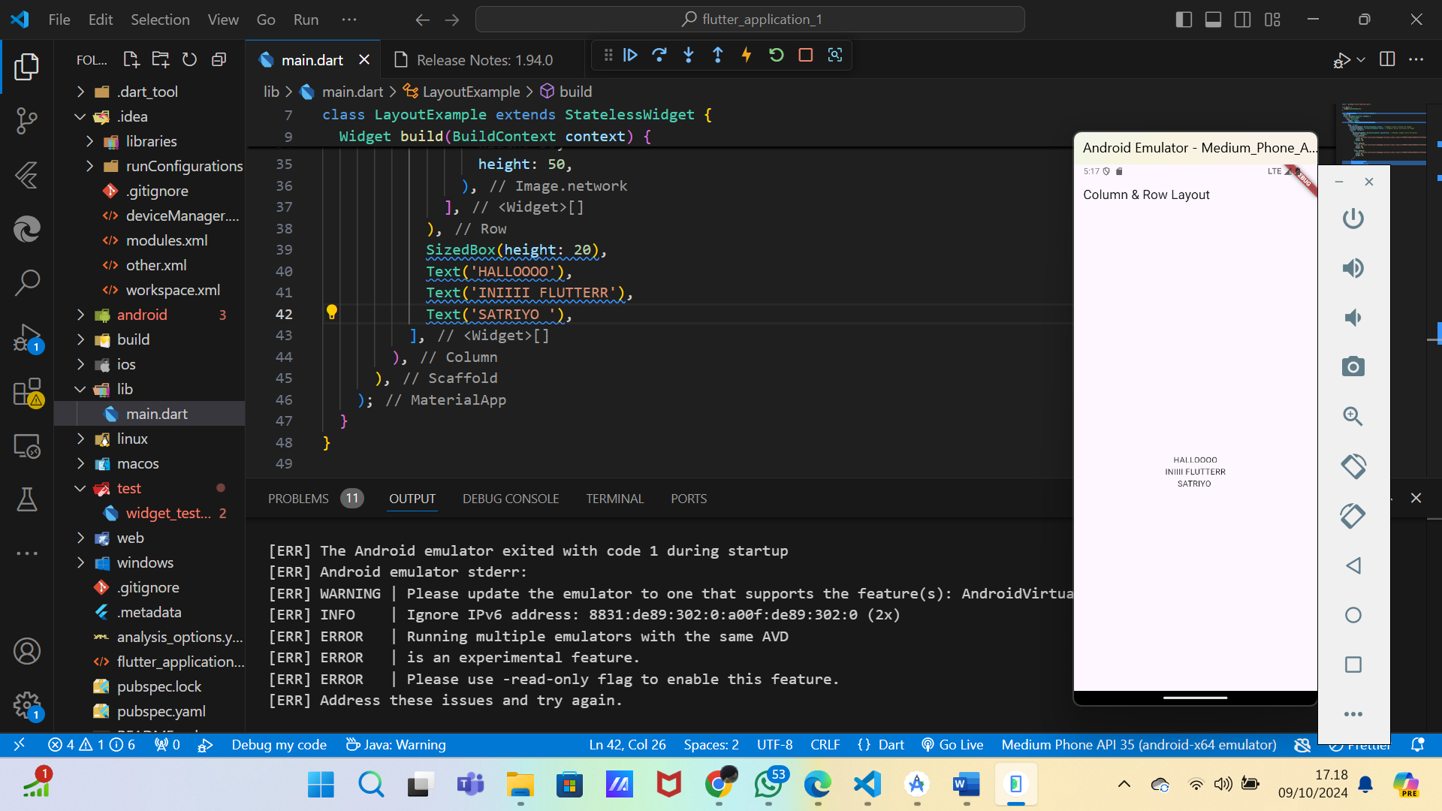

**2. Coba buat layout menggunakan Stack untuk menumpuk beberapa widget, lalu gunakan Positioned untuk mengatur posisi mereka dengan lebih detail.**

import 'package:flutter/material.dart';

void main() {

runApp(StackLayoutExample());

}

class StackLayoutExample extends StatelessWidget {

@override

Widget build(BuildContext context) {

return MaterialApp(

home: Scaffold(

appBar: AppBar(

title: Text('Stack Layout'),

),

body: Stack(

children: <Widget>[

Container(

width: 300,

height: 300,

color: Colors.blue,

),

Positioned(

top: 50,

left: 50,

child: Container(

width: 200,

height: 200,

color: Colors.red,

),

),

Positioned(

top: 100,

left: 100,

child: Container(

width: 100,

height: 100,

color: Colors.green,

),

),

],

),

),

);

}

}

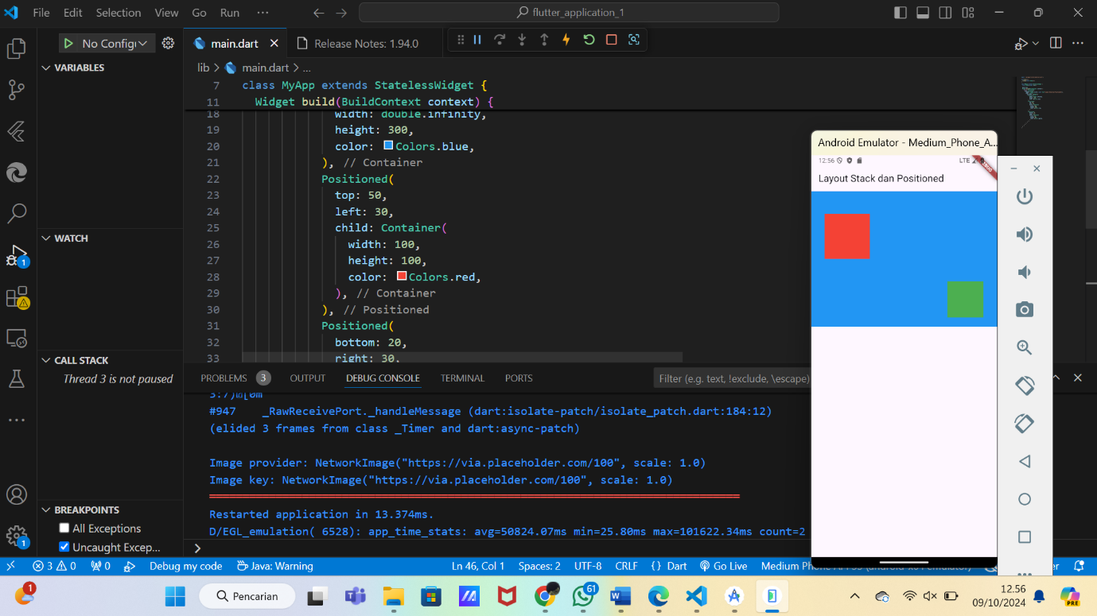

**3. Eksperimen dengan Expanded dan Flexible dalam Row dan Column. Amati bagaimana mereka mempengaruhi tata letak widget ketika ukuran layar berubah.**

import 'package:flutter/material.dart';

void main() {

runApp(ExpandedFlexibleExample());

}

class ExpandedFlexibleExample extends StatelessWidget {

@override

Widget build(BuildContext context) {

return MaterialApp(

home: Scaffold(

appBar: AppBar(

title: Text('Expanded & Flexible Example'),

),

body: Column(

children: <Widget>[

Row(

children: <Widget>[

Expanded(

child: Container(

height: 100,

color: Colors.red,

child: Center(child: Text('Expanded')),

),

),

Container(

width: 100,

height: 100,

color: Colors.blue,

child: Center(child: Text('Fixed')),

),

],

),

Row(

children: <Widget>[

Flexible(

flex: 2,

child: Container(

height: 100,

color: Colors.green,

child: Center(child: Text('Flexible 2x')),

),

),

Flexible(

flex: 1,

child: Container(

height: 100,

color: Colors.purple,

child: Center(child: Text('Flexible 1x')),

),

),

],

),

],

),

),

);

}

}

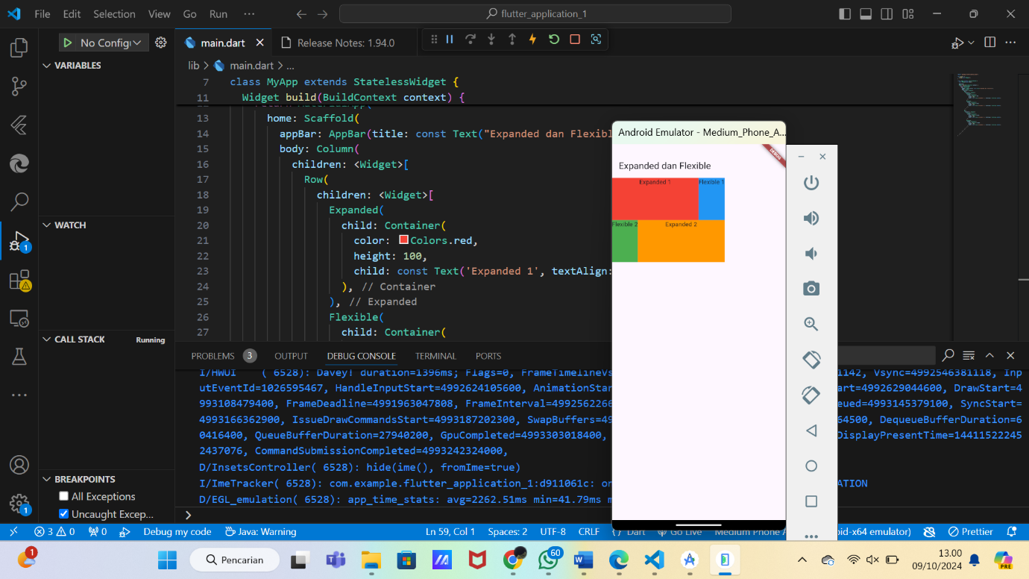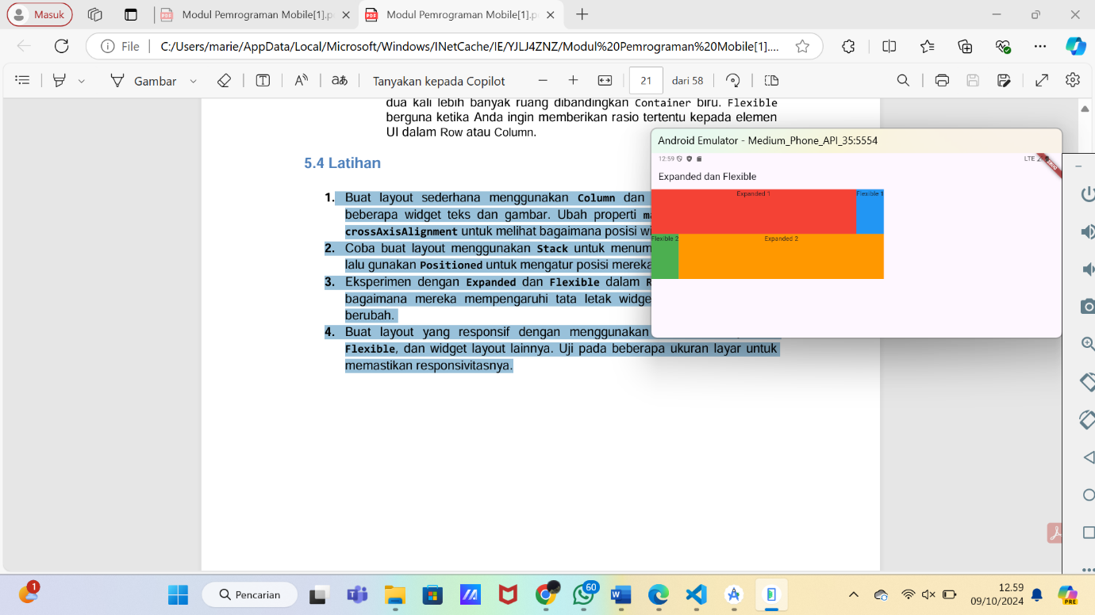

**4. Buat layout yang responsif dengan menggunakan kombinasi Expanded, Flexible, dan widget layout lainnya. Uji pada beberapa ukuran layar untuk memastikan responsivitasnya.**

import 'package:flutter/material.dart';

void main() {

runApp(ResponsiveLayoutExample());

}

class ResponsiveLayoutExample extends StatelessWidget {

@override

Widget build(BuildContext context) {

return MaterialApp(

home: Scaffold(

appBar: AppBar(

title: Text('Responsive Layout Example'),

),

body: Column(

children: <Widget>[

Expanded(

child: Container(

color: Colors.orange,

child: Center(child: Text('Expanded - Fill all space')),

),

),

Row(

children: <Widget>[

Flexible(

flex: 1,

child: Container(

height: 100,

color: Colors.green,

child: Center(child: Text('Flexible 1x')),

),

),

Flexible(

flex: 2,

child: Container(

height: 100,

color: Colors.red,

child: Center(child: Text('Flexible 2x')),

),

),

],

),

Row(

children: <Widget>[

Expanded(

child: Container(

height: 100,

color: Colors.purple,

child: Center(child: Text('Expanded')),

),

),

Container(

width: 100,

height: 100,

color: Colors.blue,

child: Center(child: Text('Fixed Width')),

),

],

),

],

),

),

);

}

}